**Daily Scrum or Standup Meeting**

Team name: Group 2

Scrum Master: Max Edwards

Date:_____________________February 21 2023__________

| **Team Member** | **What did you do since the last scrum?** | **What do you plan to do before the next scrum?** | **What obstacles do you have?** |
| --- | --- | --- | --- |
| Satchell Fausett | Created endpoint for user moneys | Add dummy data | Internship/ engagement |
| Jared Hansen | Approved the pull request  Fixed the calendar UI | Make vehicle display component | Reptile tracker  Earlier due dates |
| Chase Miller | Create user  Authenticate | Create Vehicle | Other classes |
| Max Edwards | Login page  NavBar  AuthContext login feature | Create account homepage | Slightly ill. Recovery |
|  |  |  |  |

# Burndown

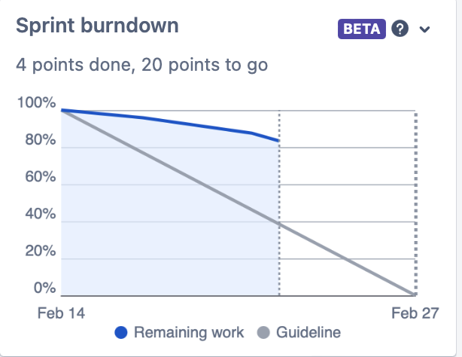

# Screenshot of you project board

